**INTERNSHIP REPORT**

**ON**

# PYTHON COMPITATIVE CODEING

**A internship Report is submitted In accordance with requirement of degree of**

**BACHELOR OF TECHNOLOGY IN**

**Computer science and information technology**

Submitted by

N.AKHILA

21KQ1A0720

Under the Mentorship of

## M.SHRAVAN KUMAR



**DEPARTMENT OF Computer science and information technology**

PACE INSTITUTE OF TECNOLOGY AND SCIENCES

(AUTONOMOUS)

(Affiliated to Jawaharlal Nehru Technological University Kakinada, Kakinada & Accredited by NAAC ‘A’ GRADE,. An ISO 9001-2015 Certified Institution)

NH-16, Valluru Post , Prakasam District, A.P-523272.

CAMPUS CHOICE PREDICTOR

DESCRIPITION:

Campus choice predictor is the process to choose the campus based on their requirments. Students gather the information about the college based on academic performance, placements, schemes, Facilites provided by the college. Enquiring about the college from others. Few are thinking about the college near to native place. Few people thinks about the fees structure whether it is affordable or not. Some people thinks about the autonomous college or not. Some body thinks about the others opinion. This project is about finding the best college.

Requirements:-

INPUT:

1.College name

2. List of Branches in college

3.No.of placements

4.Pass percentage

5.Distance

6.Status

7.Transport

OUTPUT:

1.Details of particular college

2.College name with placements greater than 500

3.Transport available college names

4.No.of autonomous colleges

5.Branches of particular college

6.College that are less distance

7.college names with pass percentage greater than 60

8.Which college has max placements

FUNCTIONS:

Conditions, Lists, Sets, Dictionary, max(), pandas

APPROACH:

## User Input:

## The code allows users to enter information for a specified number of colleges. College details include name, branches (as a list), placements, percentage, distance, status (autonomous/non-autonomous), and transport availability.

## Data Storage and Display:

## It stores the entered data in a list of dictionaries (l). The code displays the college details in a tabular format.

## 3. DataFrame Creation:

## It creates a Pandas DataFrame (df) from the list l.

## 4. College Search:

## It allows users to search for a specific college by name and displays its details.

## 5. Filtering:

## It can filter colleges based on: Placements greater than 500 Transport availability ("yes") Percentage greater than 60 Autonomous status ("autonomous") 6. Analysis:

It calculates and displays the number of autonomous colleges.

source code:

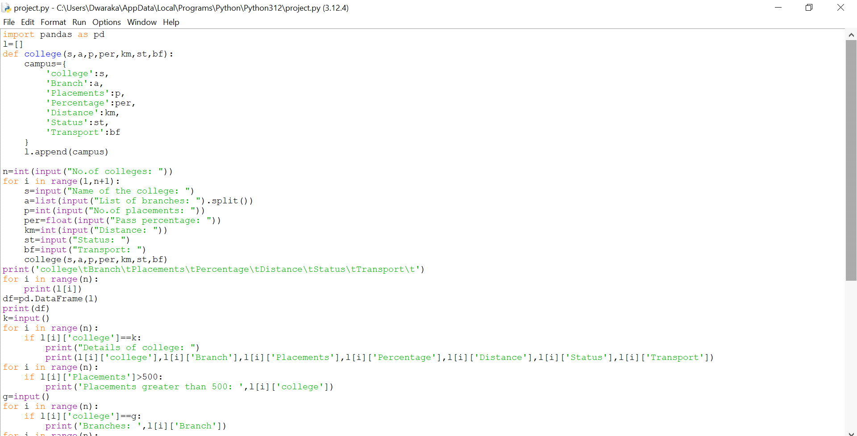

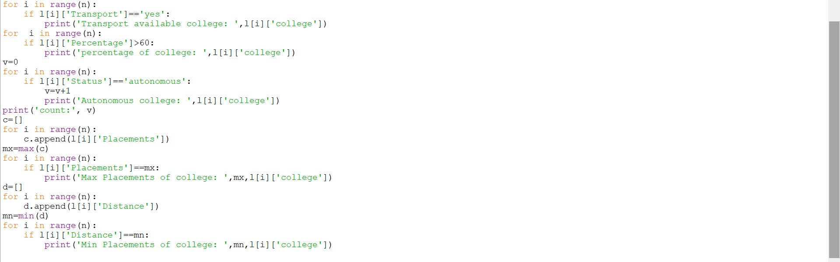

Output:

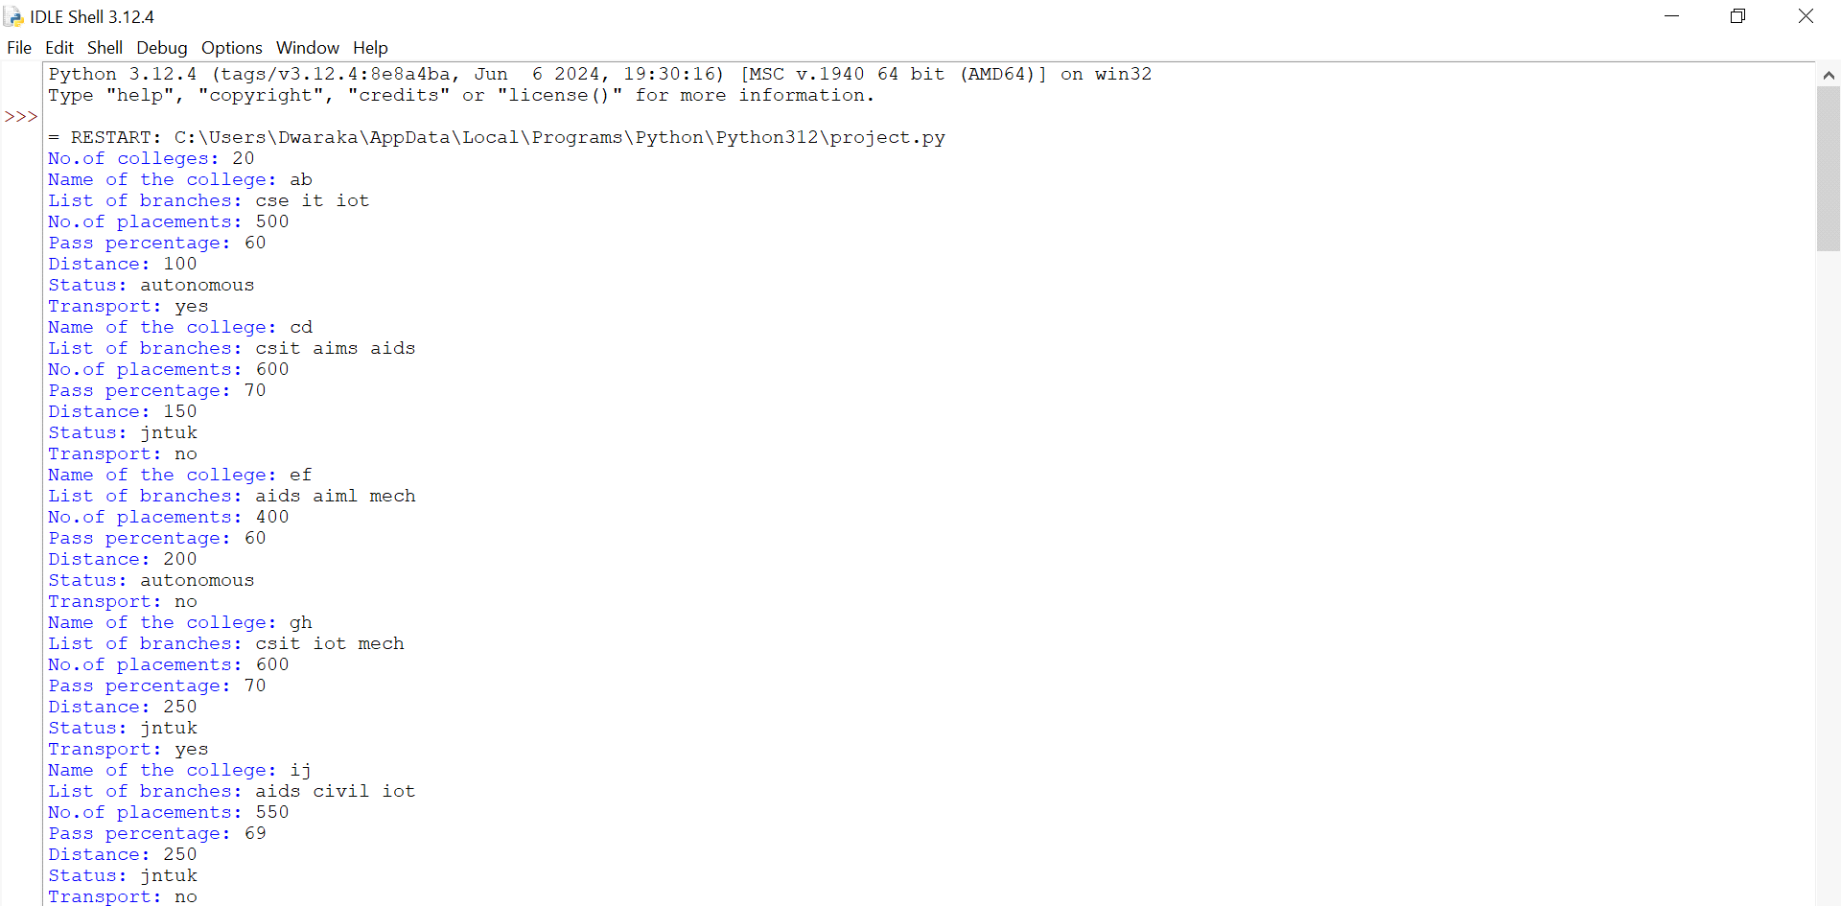

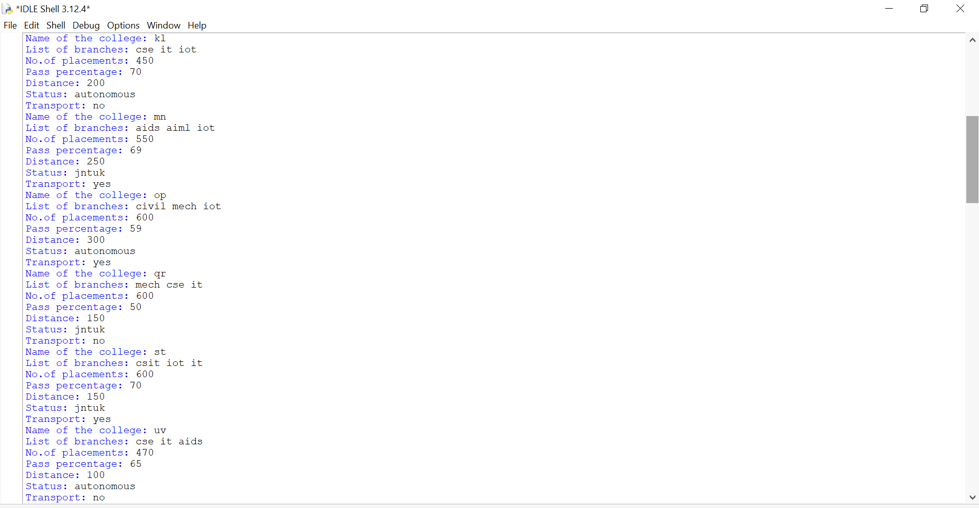

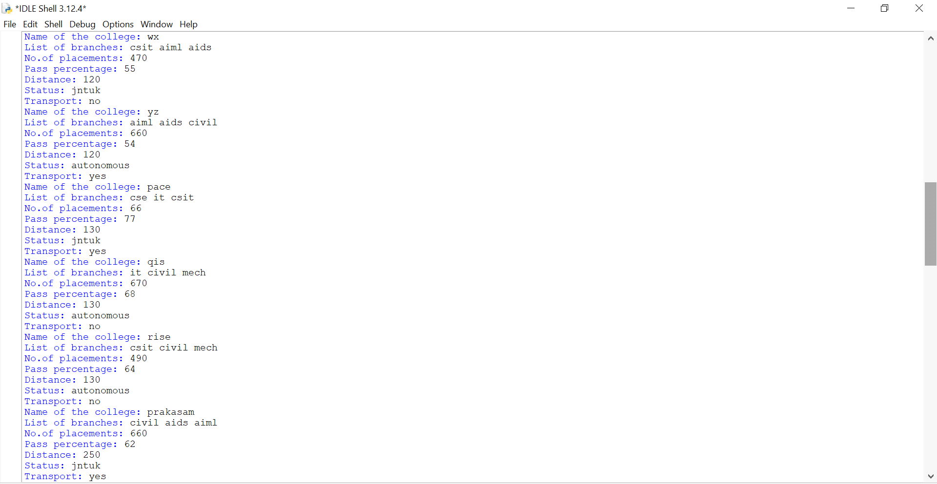

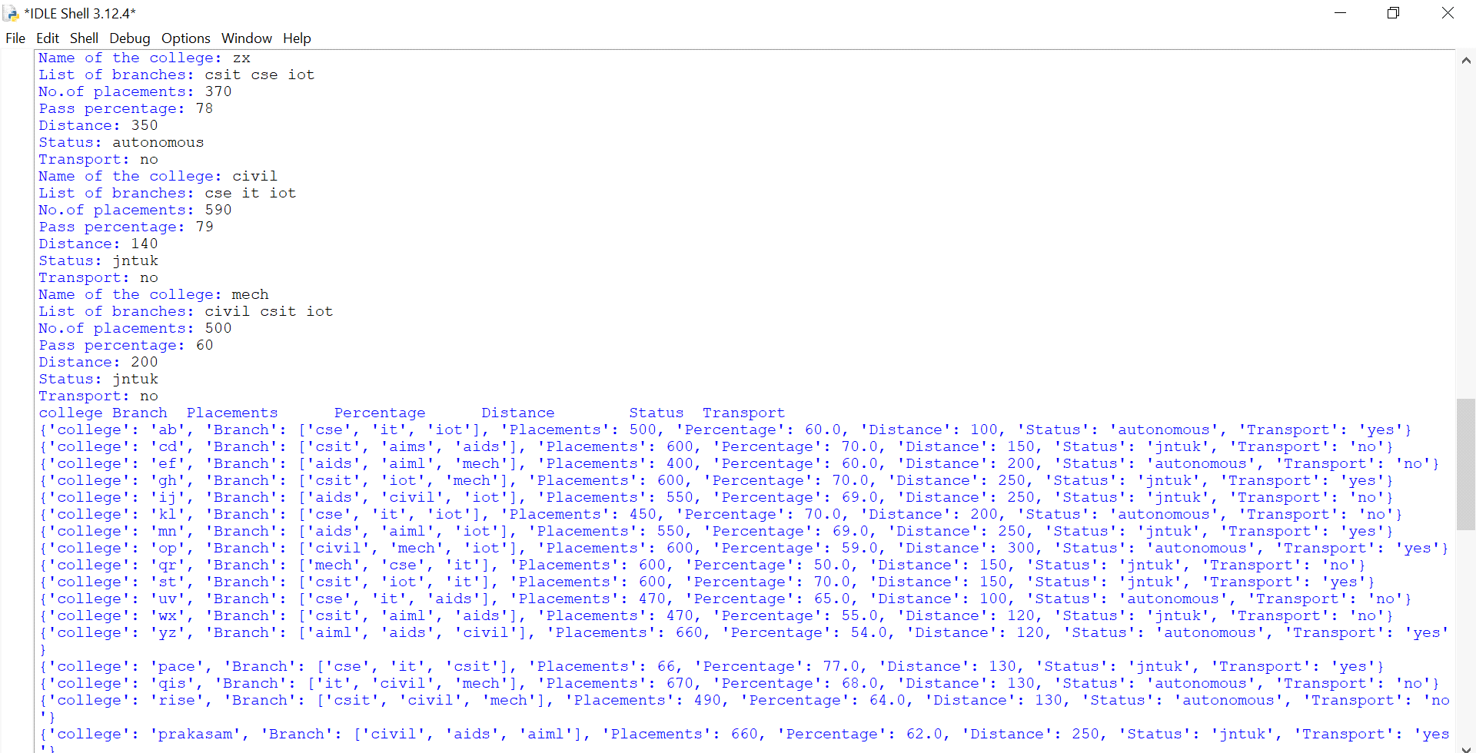

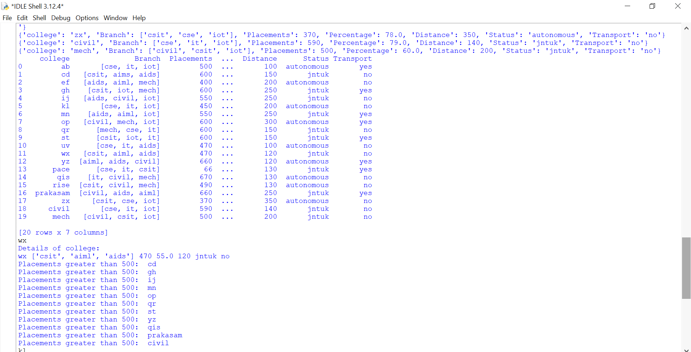

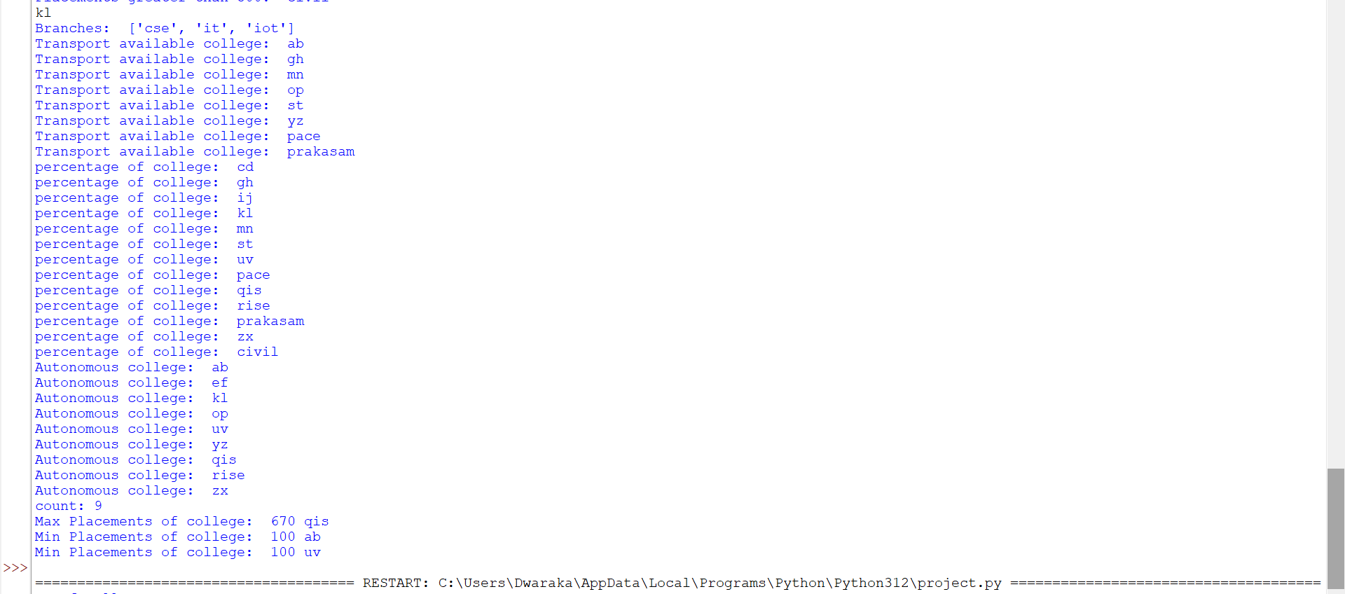

Conclusion:-

The Campus Choice Predictor, implemented entirely using Python, provides a practical tool for assisting students in selecting the most suitable college based on their individual profiles and preferences. By utilizing Python’s powerful libraries and straightforward syntax, the project achieves robust and efficient data processing, analysis, and prediction.